|  |  |
| --- | --- |
| Date | 19 September 2022 |
| Team ID | PNT2022TMID19105 |
| Project Name | Smart Farmer-IOT Enabled Smart Farming Application |
| Maximum marks | 4 Marks |

**Project Design Phase-I**

**Solution Architecture**

**Solution Architecture:**

1.The different soil parameters (temperature, humidity, light intensity, pH level) are sensed using different sensors and the obtained value is stored in IBM cloud.

2. Arduino UNO is used as a processing unit which processes the data obtained fromsensors and weather data from weather API.

3. Node red is used as a programming tool to wire the hardware, software and APIs.The MQTT protocol is followed for communication.

4. All the collected data are provided to the user through a mobile application which was developed using MIT app inventor. The user could make decision through an app, whether to water the crop or not depending upon the sensor values.

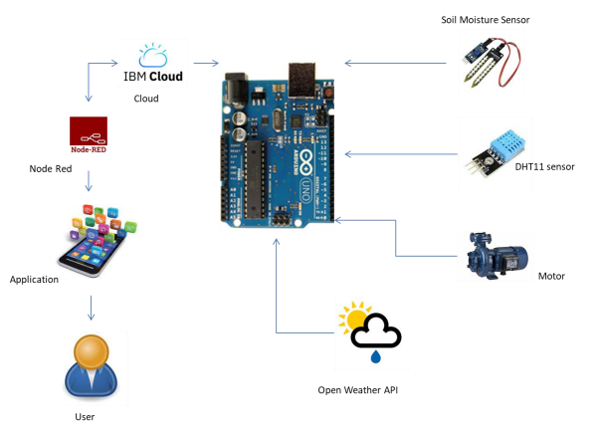**Solution Architecture Diagram:**